PHASE 2
Design Document

<<Title>>
Picture

Developed by Nsovo Ngobeni

Signoffs
Phase | Teacher | Date | Signature
2) Design Document | Mrs Rajamany

1. Summary
≪Describe the actual design elements of the system. Specify all known components needed to deliver a complete system≫
The app will have 4 screens, each with their own UI elements:
Screen 1: Timer Screen
The first screen is the timer screen that will let users record and track all their entries and show a quick preview of their currents stats. The screen will contain the following UI elements:
- A digital timer
- Navigation to other screens
- Control buttons (Start, Stop, Restart, Penalty, and DNF)
Screen 2: Trainer Screen
The trainer screen will help users learn and perfect the skill they need to become faster solvers. The screen will have:
- A list of all the algorithms and their stats
- Controls to practice an algorithm
- A button to mark your proficiency with the algorithm
Screen 3: Stats Screen
The stats screen will show all the players relevant stats in a graphical manner. It will include:
- Blocks Components displaying specific stats
Screen 4: Help Screen
The help screen will display guides explaining the use and function of the app to the users. It will contain text alongside pictorial representations.

2. Interface Design ➔ GUI screens
≪This section summarizes the layouts of all the various screen layouts for the entire program. This section should describe ALL interfaces linking the program to the outside environment including the user and should detail all the screens needed to deliver all the functional requirements. Include screen descriptions, screen shots, data sources and data descriptions. The client should understand that the final product may not be exactly as listed here but the functionality will stay the same. During coding, we may merge or separate screens to achieve a nicer user interface and to promote reusability of components. ≫

These separate interface elements / environments are described in detail below:

≪Do the following for each screen: Draw a screen design AND fill in a description table. Screen captures from a design tool (including IDE), sketches and mock-ups are acceptable. N.B. No code is needed for this section.≫

Timer Screen:
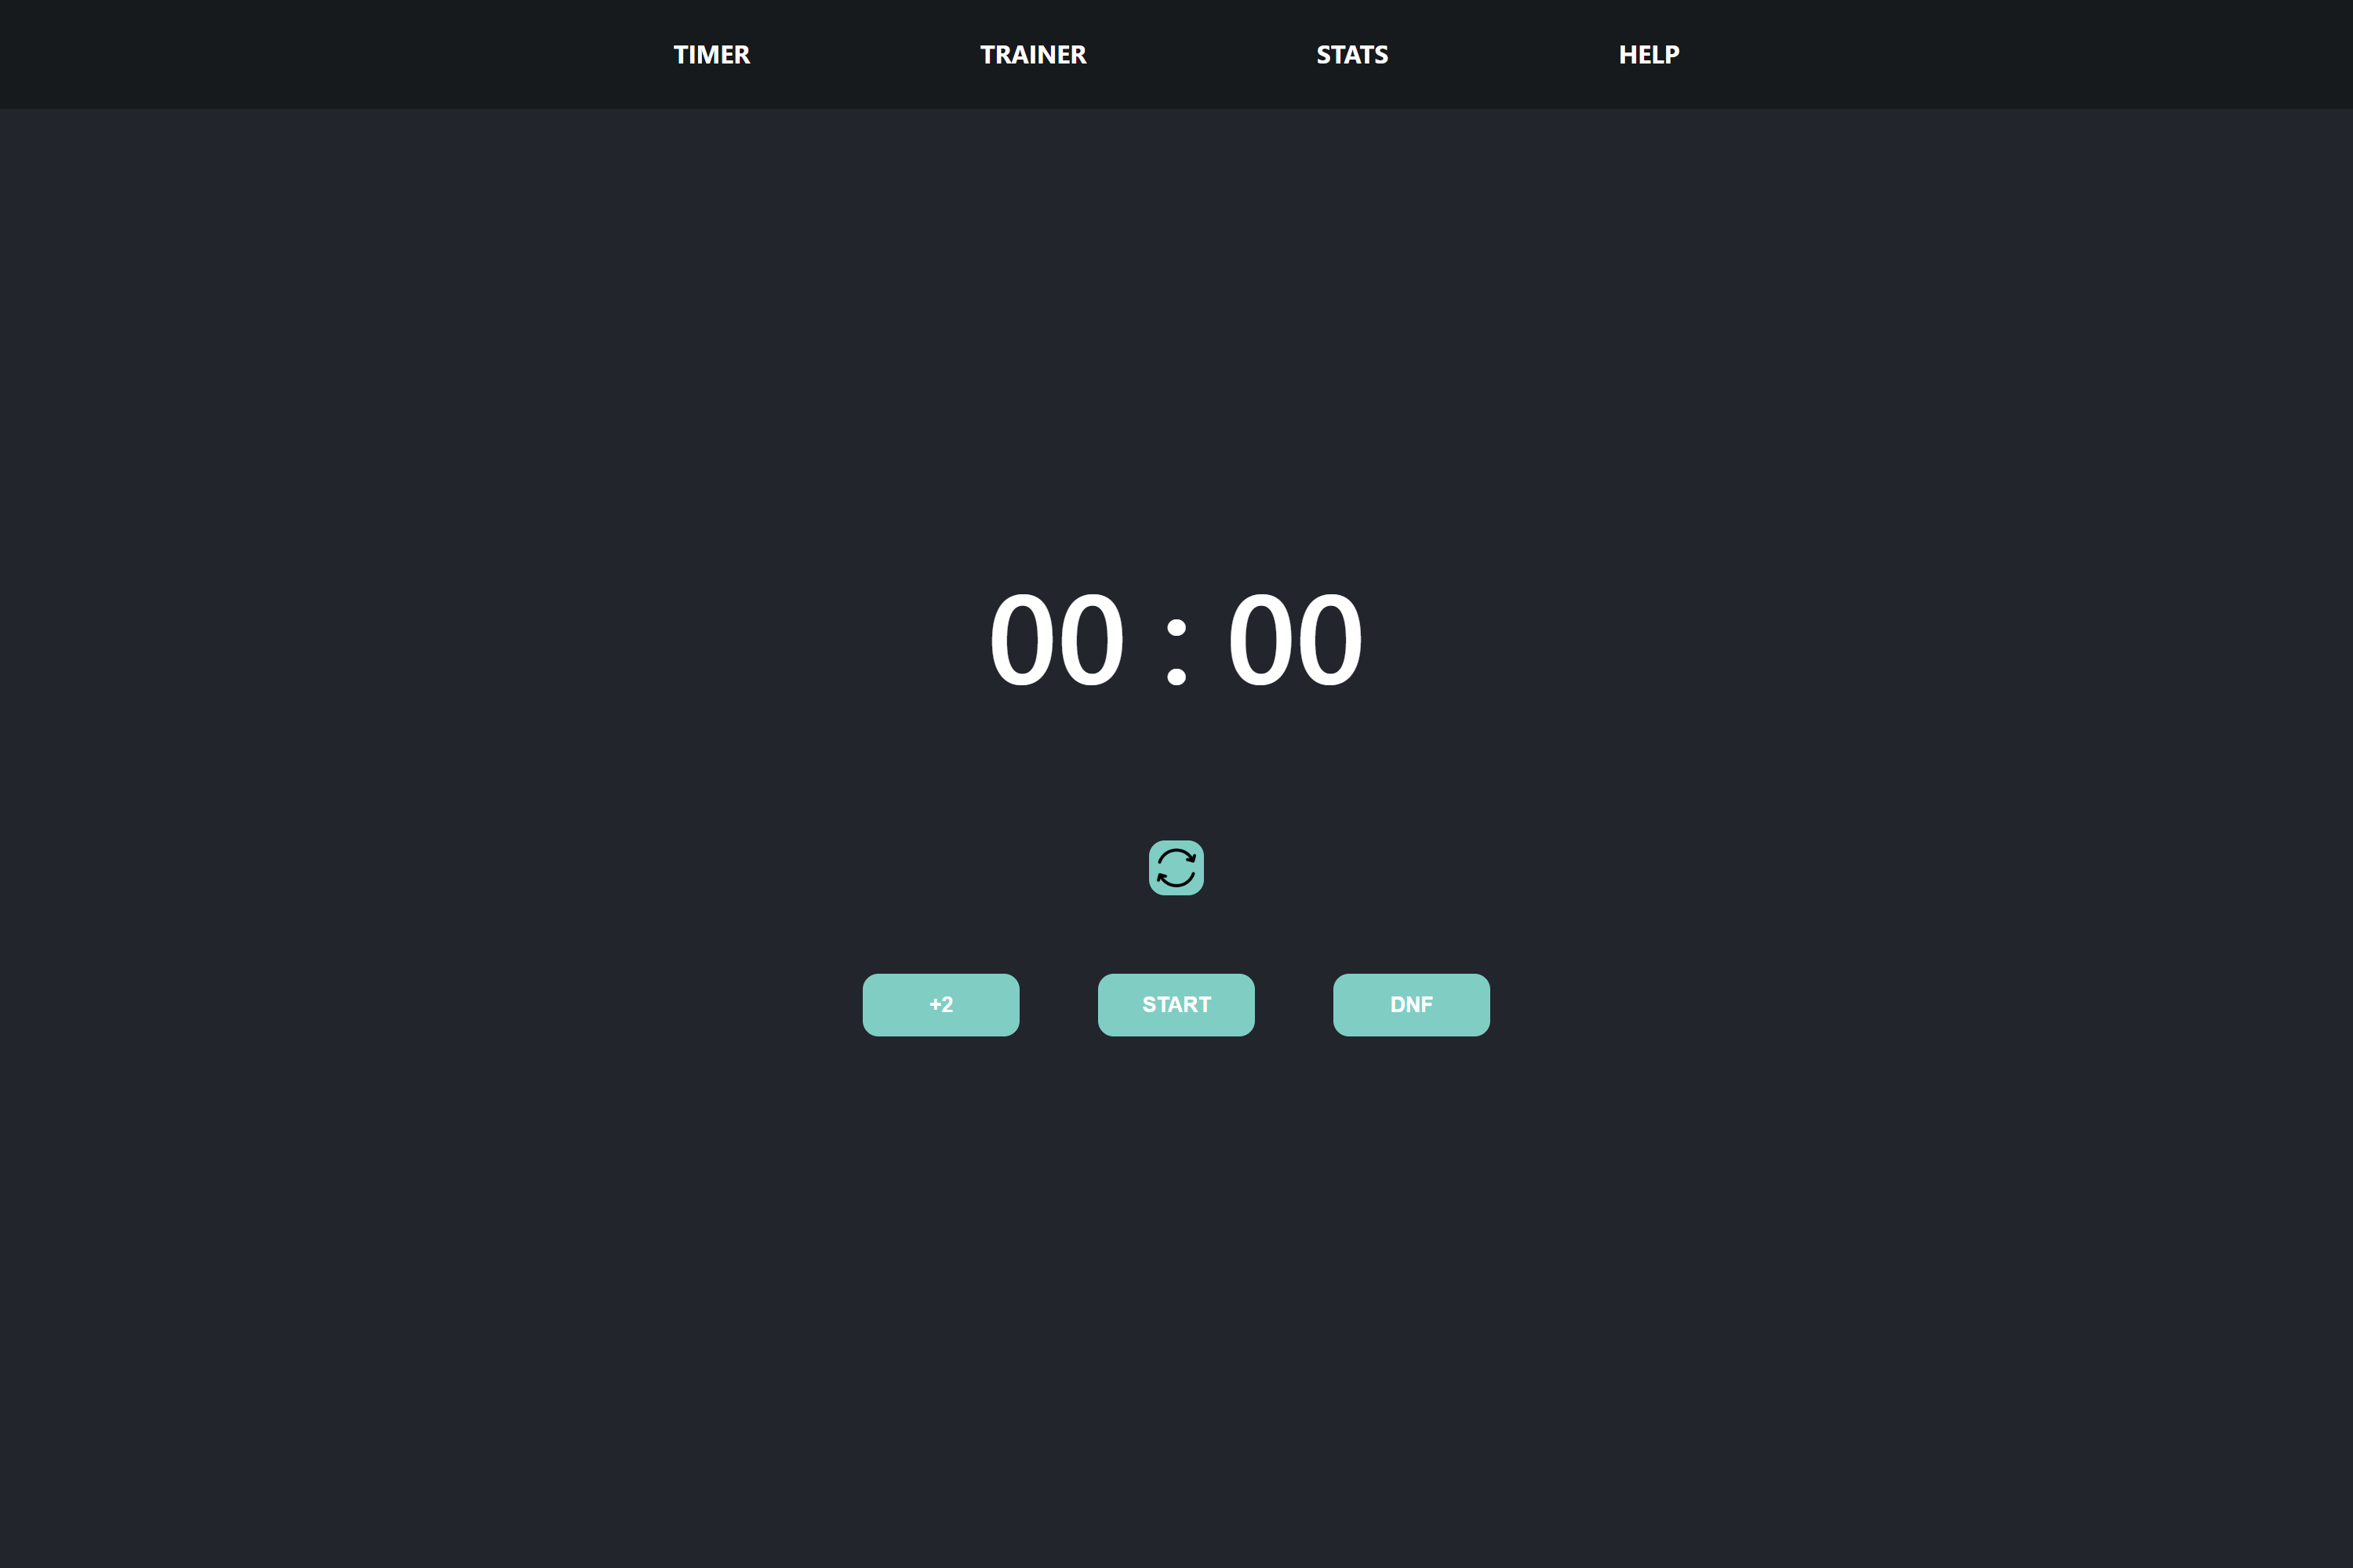

Description | The screen will let users record and save their times. Times recorded will be stored in the database of solves
Security Group | Logged in users can access all their own data
Data | Time (in milliseconds): number  Data will be stored in solves database
Actions | Reset Button: Resets the time to 00:00  +2 Button: Adds a 2 second penalty to the users final time  Start Button: Starts the timer  Stop Button: Stops the timer and records the time  DNF Button: Time gets recorded as null  (Start & Stop button interchange based on the timer running)

Stats Screen:
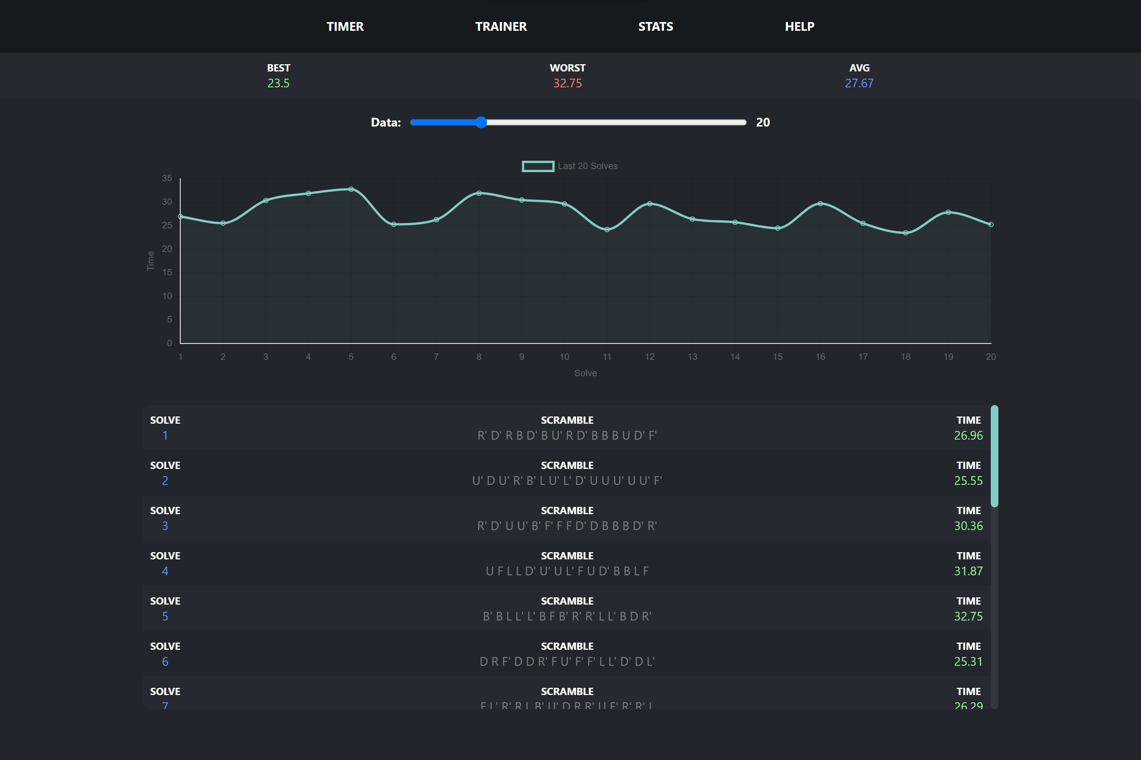

Description | The screen displays the users solve times through a dynamically rendered graph and list that update as the users results change and are added/removed
Security Group | Logged in users can access all their own data
Data | ID: Scramble + Time  Scramble: text field  Time (in millieseconds): Number
Actions | Users can change how much of their data will be loaded. The last x solves will be loaded based on the value of the slider at the top of the screen

Trainer Screen:
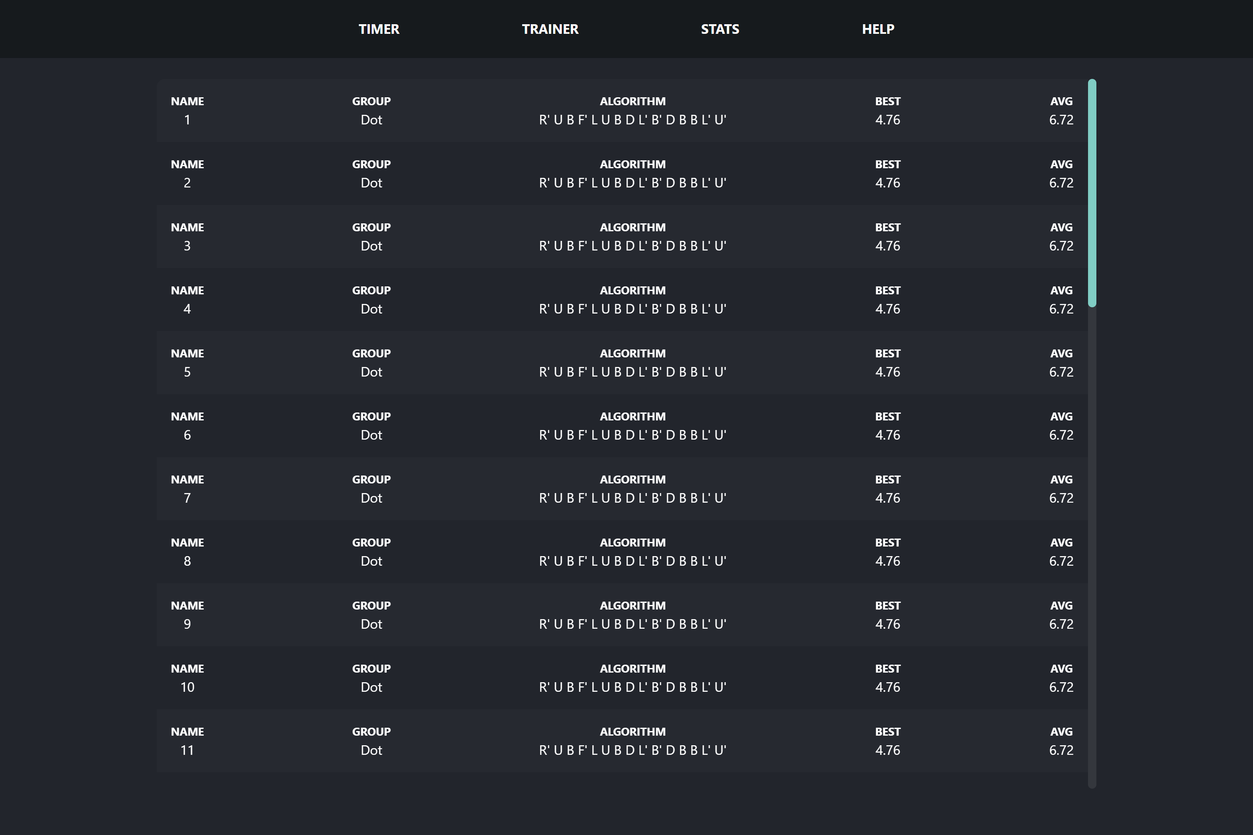

Description | The screen displays algorithms used to solve the cube and allows users to practice these algorithms and improve their times
Security Group | Logged in users can access all their own data
Data | Name: Text field  Group: Text field  Algorithm: Text field  Best Time: Number  Average Time: Number  All data comes from algorithms database and is rendered dynamically on the screen
Actions | Clicking an algorithm cell trigger a popup that will let users record their time

Popup Screen:
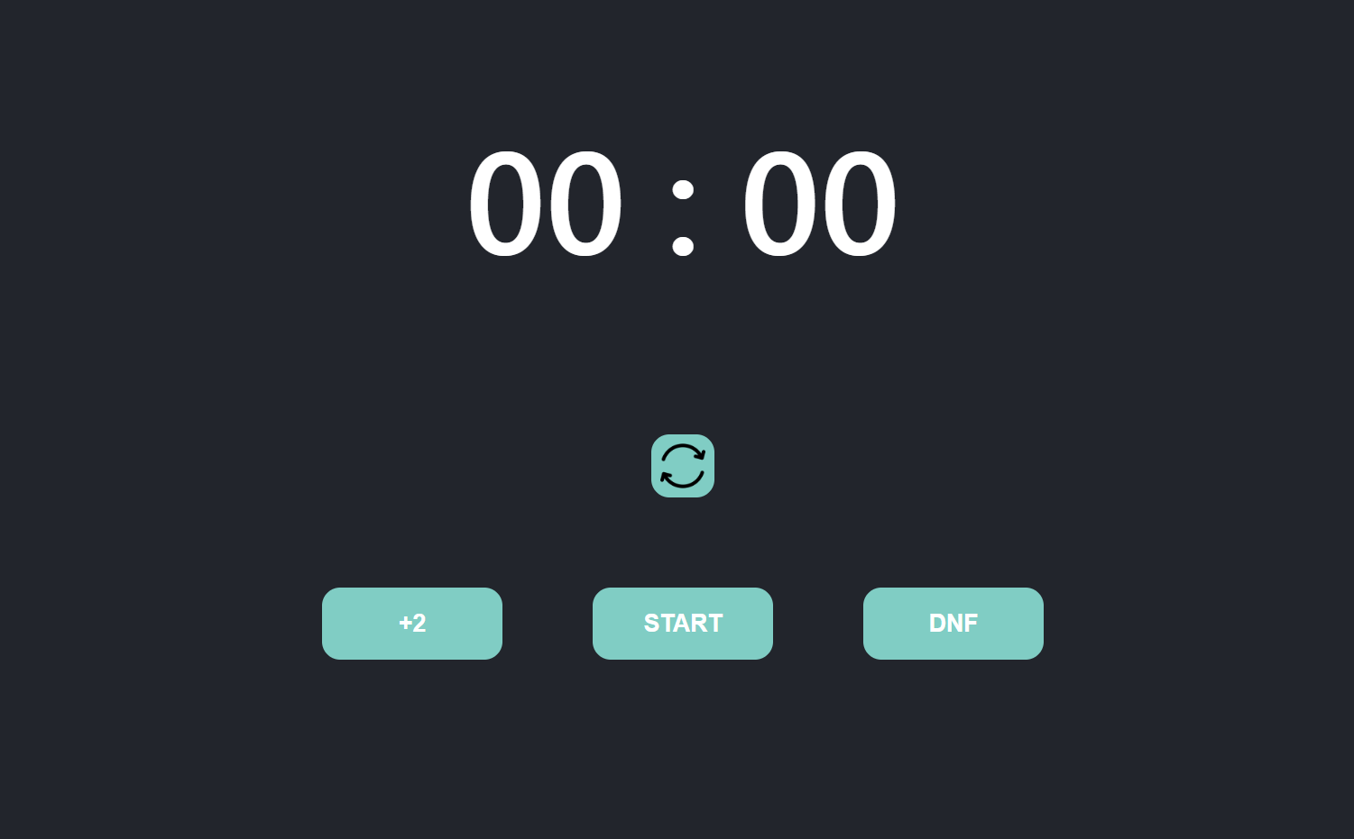

Description | The screen lets users record times for specific algorithms. It a reused version of the timer
Security Group | Logged in users can access all their own data. Data can also be recorded
Data | Time (in milliseconds): Number
Actions | Reset Button: Resets the time to 00:00  +2 Button: Adds a 2 second penalty to the users final time  Start Button: Starts the timer  Stop Button: Stops the timer and records the time  DNF Button: Time gets recorded as null  (Start & Stop button interchange based on the timer running)

3. Program Flow ➔ Sequencing
≪Here you write down the sequence/flow of events that would happen in your program. Write it as a bulleted list. Must break sequencing into sections to cover all aspects of the functions and features of the specification document. Flow must be clear, well represented and easy to understand. NO LOGIC GAPS! The essential part(s) of the program must be planned using either Flow Diagram(s) or Algorithm(s). HINT: Copy in your features from your specification document as framework, and then fill in the sequencing, that way you will fulfill the specifications. Add in algorithm / SQL statements to explain more complex points. DO NOT do algorithms for basic programming techniques that were covered in class, e.g. sorting.≫

- ≪Screen 1, e.g. welcome screen is displayed≫
  - ≪Description, e.g. user types in username and password≫
  - ≪Description, e.g. user clicks on OK button≫
  - ≪Description, e.g. program tests if …… then ….≫
- ≪Screen2, e.g. main screen with menus≫
  - ≪Description, e.g. if user chooses menu Insert
    - ≪Description, e.g. the user ……≫

4. Class design ➔ Objects / Classes to be developed
≪You must design every class AND explain your choice of classes, fields and methods. Methods and fields must clearly relate back to the specifications document!≫

≪Fill in the following for each class ≫
Class Name:
Purpose of class:
Fields
Field Name | Data type | Description
Methods
Method name | Data type (if typed) / void | Description

5. Secondary Storage Design ➔ Database Layer
≪You must make use of persistent storage design! Explain what your data structures are – if reading from text files / typed files, specify their format. Databases need to be described in detail. Correct data types must be used! For text files, an explanation of the structure of the file must be provided together with sample data. Storage can be local, remote or cloud based. Data types used must be appropriate to the purpose and match the specification document requirements.≫

≪Do the following for each table in a database:≫

Table name:
Links / Relationships:
Fields: | Field name | Data type | Description

≪For any text file used, explain the layout, e.g. name, surname and password≫

Explanation of secondary data storage
≪You must explain your choice of data storage and fields and data types. Describe which data is stored how and why you chose to store it this way. The explanation must demonstrate a justification of the secondary storage design and an understanding of the implications of the chosen design≫

Explanation of Primary Data Structure related to Secondary Storage
<< Provide a description of how the primary data structure described in the class diagrams will represent the secondary storage design. There should be a description for each backend class listed in the class diagrams above that will translate the data to and from secondary storage >>

